LAB WEEK 06

We need a blog web application that allow people publishes their post. The infoemation of each object that related to our web are descript as below

**User Table**

In this section, we will design the **User Table** to store user information of all the post authors. The same table can be used to relate the post authors so that all the authors can manage their own posts. Below mentioned is the description of all the columns of the User Table.

|  |  |
| --- | --- |
| **Id** | The unique id to identify the user. |
| **First Name** | The first name of the user. |
| **Middle Name** | The middle name of the user. |
| **Last Name** | The last name of the user. |
| **Mobile** | The mobile number of the user. It can be used for login and registration purposes. |
| **Email** | The email of the user. It can be used for login and registration purposes. |
| **Password Hash** | The password hash generated by the appropriate algorithm. We must avoid storing plain passwords. |
| **Registered At** | This column can be used to calculate the life of the user with the blog. |
| **Last Login** | It can be used to identify the last login of the user. |
| **Intro** | The brief introduction of the Author to be displayed on each post. |
| **Profile** | The author details to be displayed on the Author Page. |

**Post Table**

In this section, we will design the **Post Table** to store the post data. Below mentioned is the description of all the columns of the Post Table.

|  |  |
| --- | --- |
| **Id** | The unique id to identify the post. |
| **Author Id** | The author id to identify the post author. |
| **Parent Id** | The parent id to identify the parent post. It can be used to form the table of content of the parent post of series. |
| **Title** | The post title to be displayed on the Post Page and the lists. |
| **Meta Title** | The meta title to be used for browser title and SEO. |
| **Summary** | The summary of the post to mention the key highlights. |
| **Published** | It can be used to identify whether the post is publicly available. |
| **Created At** | It stores the date and time at which the post is created. |
| **Updated At** | It stores the date and time at which the post is updated. |
| **Published At** | It stores the date and time at which the post is published. |
| **Content** | The column used to store the post data. |

**Post Comment Table**

In this section, we will design the **Post Comment Table** to store the post comments. Below mentioned is the description of all the columns of the Post Comment Table.

|  |  |
| --- | --- |
| **Id** | The unique id to identify the post comment. |
| **Post Id** | The post id to identify the parent post. |
| **Parent Id** | The parent id to identify the parent comment. |
| **Title** | The comment title. |
| **Published** | It can be used to identify whether the comment is publicly available. |
| **Created At** | It stores the date and time at which the comment is submitted. |
| **Published At** | It stores the date and time at which the comment is published. |
| **Content** | The column used to store the comment data. |

Create a Spring web application with name lab-week-05, select uploading to Git hub.

Use JPA mapping these tables. You can compare with the reference database as follow.

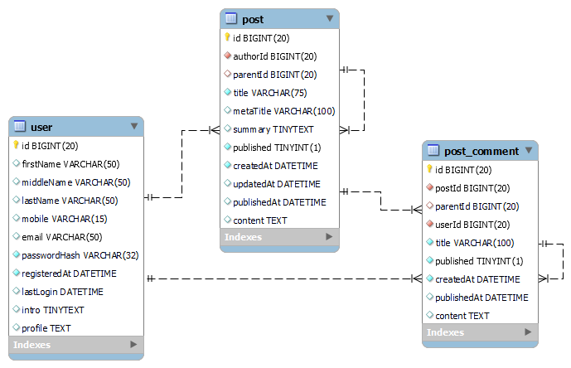

|  |
| --- |
| **DROP** **DATABASE** **IF** **EXISTS** `blog`;  **CREATE** **DATABASE** **IF** **NOT** **EXISTS** `blog` */*!40100 DEFAULT CHARACTER SET latin1 COLLATE latin1_swedish_ci */*;  **USE** `blog`;  *-- Dumping structure for table blog.post*  **DROP** **TABLE** **IF** **EXISTS** `post`;  **CREATE** **TABLE** **IF** **NOT** **EXISTS** `post` (  `id` **bigint**(20) **NOT** **NULL** **AUTO_INCREMENT**,  `authorId` **bigint**(20) **NOT** **NULL**,  `parentId` **bigint**(20) **DEFAULT** **NULL**,  `title` **varchar**(75) **NOT** **NULL**,  `metaTitle` **varchar**(100) **DEFAULT** **NULL**,  `summary` **tinytext** **DEFAULT** **NULL**,  `published` **tinyint**(1) **NOT** **NULL** **DEFAULT** 0,  `createdAt` **datetime** **NOT** **NULL**,  `updatedAt` **datetime** **DEFAULT** **NULL**,  `publishedAt` **datetime** **DEFAULT** **NULL**,  `content` **text** **DEFAULT** **NULL**,  **PRIMARY** **KEY** (`id`),  **KEY** `idx_post_user` (`authorId`),  **KEY** `idx_post_parent` (`parentId`),  **CONSTRAINT** `fk_post_parent` **FOREIGN** **KEY** (`parentId`) **REFERENCES** `post` (`id`) **ON** **DELETE** **NO** **ACTION** **ON** **UPDATE** **NO** **ACTION**,  **CONSTRAINT** `fk_post_user` **FOREIGN** **KEY** (`authorId`) **REFERENCES** `user` (`id`) **ON** **DELETE** **NO** **ACTION** **ON** **UPDATE** **NO** **ACTION**  ) **ENGINE**=**InnoDB** **DEFAULT** **CHARSET**=**latin1** **COLLATE**=**latin1_swedish_ci**;  *-- Data exporting was unselected.*  *-- Dumping structure for table blog.post_comment*  **DROP** **TABLE** **IF** **EXISTS** `post_comment`;  **CREATE** **TABLE** **IF** **NOT** **EXISTS** `post_comment` (  `id` **bigint**(20) **NOT** **NULL** **AUTO_INCREMENT**,  `postId` **bigint**(20) **NOT** **NULL**,  `parentId` **bigint**(20) **DEFAULT** **NULL**,  `title` **varchar**(100) **NOT** **NULL**,  `published` **tinyint**(1) **NOT** **NULL** **DEFAULT** 0,  `createdAt` **datetime** **NOT** **NULL**,  `publishedAt` **datetime** **DEFAULT** **NULL**,  `content` **text** **DEFAULT** **NULL**,  **PRIMARY** **KEY** (`id`),  **KEY** `idx_comment_post` (`postId`),  **KEY** `idx_comment_parent` (`parentId`),  **CONSTRAINT** `fk_comment_parent` **FOREIGN** **KEY** (`parentId`) **REFERENCES** `post_comment` (`id`) **ON** **DELETE** **NO** **ACTION** **ON** **UPDATE** **NO** **ACTION**,  **CONSTRAINT** `fk_comment_post` **FOREIGN** **KEY** (`postId`) **REFERENCES** `post` (`id`) **ON** **DELETE** **NO** **ACTION** **ON** **UPDATE** **NO** **ACTION**  ) **ENGINE**=**InnoDB** **DEFAULT** **CHARSET**=**latin1** **COLLATE**=**latin1_swedish_ci**;  *-- Data exporting was unselected.*  *-- Dumping structure for table blog.user*  **DROP** **TABLE** **IF** **EXISTS** `user`;  **CREATE** **TABLE** **IF** **NOT** **EXISTS** `user` (  `id` **bigint**(20) **NOT** **NULL** **AUTO_INCREMENT**,  `firstName` **varchar**(50) **DEFAULT** **NULL**,  `middleName` **varchar**(50) **DEFAULT** **NULL**,  `lastName` **varchar**(50) **DEFAULT** **NULL**,  `mobile` **varchar**(15) **DEFAULT** **NULL**,  `email` **varchar**(50) **DEFAULT** **NULL**,  `passwordHash` **varchar**(32) **NOT** **NULL**,  `registeredAt` **datetime** **NOT** **NULL**,  `lastLogin` **datetime** **DEFAULT** **NULL**,  `intro` **tinytext** **DEFAULT** **NULL**,  `profile` **text** **DEFAULT** **NULL**,  **PRIMARY** **KEY** (`id`),  **UNIQUE** **KEY** `uq_mobile` (`mobile`),  **UNIQUE** **KEY** `uq_email` (`email`)  ) **ENGINE**=**InnoDB** **DEFAULT** **CHARSET**=**latin1** **COLLATE**=**latin1_swedish_ci**; |